Notes from Mary McGuire: WRG November 5th Retreat on Discernment and the Holy Spirit
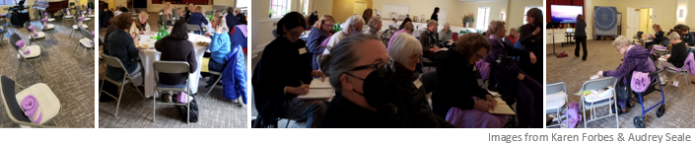 The WRG met for 4 ½ hours on Saturday, November 5 and participated in 3 hours of Discernment with parishioner Diana Benson, enjoyed a one-hour social time with salad lunch following the Discernment activities. A half hour meet-and-greet social time with a breakfast featuring pastries baked by Ann Beck preceded Diana’s presentation. Lisa Ozaeta served as online pastor for Zoom participants. Hospitality with Dani and Amanda seamlessly handled last minute technical glitches, props and furniture. A sign- up sheet to volunteer for the Altar Guild’s Christmas season’s greater need for assistance was circulated.
Diana Bender is a Board-Certified professional Coach who works with individuals who long for personal transformation in the midst of whatever life has thrown at them. She coaches executive leadership with Episcopal priests across the US and mentors the training of other coaches. She loves to lead retreats and create opportunities for people to live fully into their spiritual journeys. Diane led the Women of Epiphany on a Discernment journey.
Participants engaged individually or with partners in spiritual exercises to find the place where their “deep gladness and the world’s hunger meet” (Frederick Buechner). Diane urged each woman to feel where her deepest capacities flourish, and to differentiate that from the professional roles with which we so strongly identify. Participants asked themselves,” What loving am I made for” replacing the constant question, “What should I be doing?”
In prayer, meditation, journaling, the Women of Epiphany invited God in, provided a quiet space in their souls, allowed time for reflection in journals, and learned to be intentional in communities. Diane recommended developing ongoing Spiritual practices that created intentionality in answering God’s invitation. Spiritual practices included creating a fixed hour daily for prayer, participating in weekly worship, going on long and short Pilgrimages, living into the Liturgical Calendar, providing for one’s own personal Sabbath and rest. Women were encouraged to give spiritual control to God, including the handling of our finances through tithing, to create abundant space for the Holy Spirit to control our choices and behavior. All participants were invited to complete surveys that evaluated their experience today and provide the data needed for continuous improvement in our retreat opportunities.

