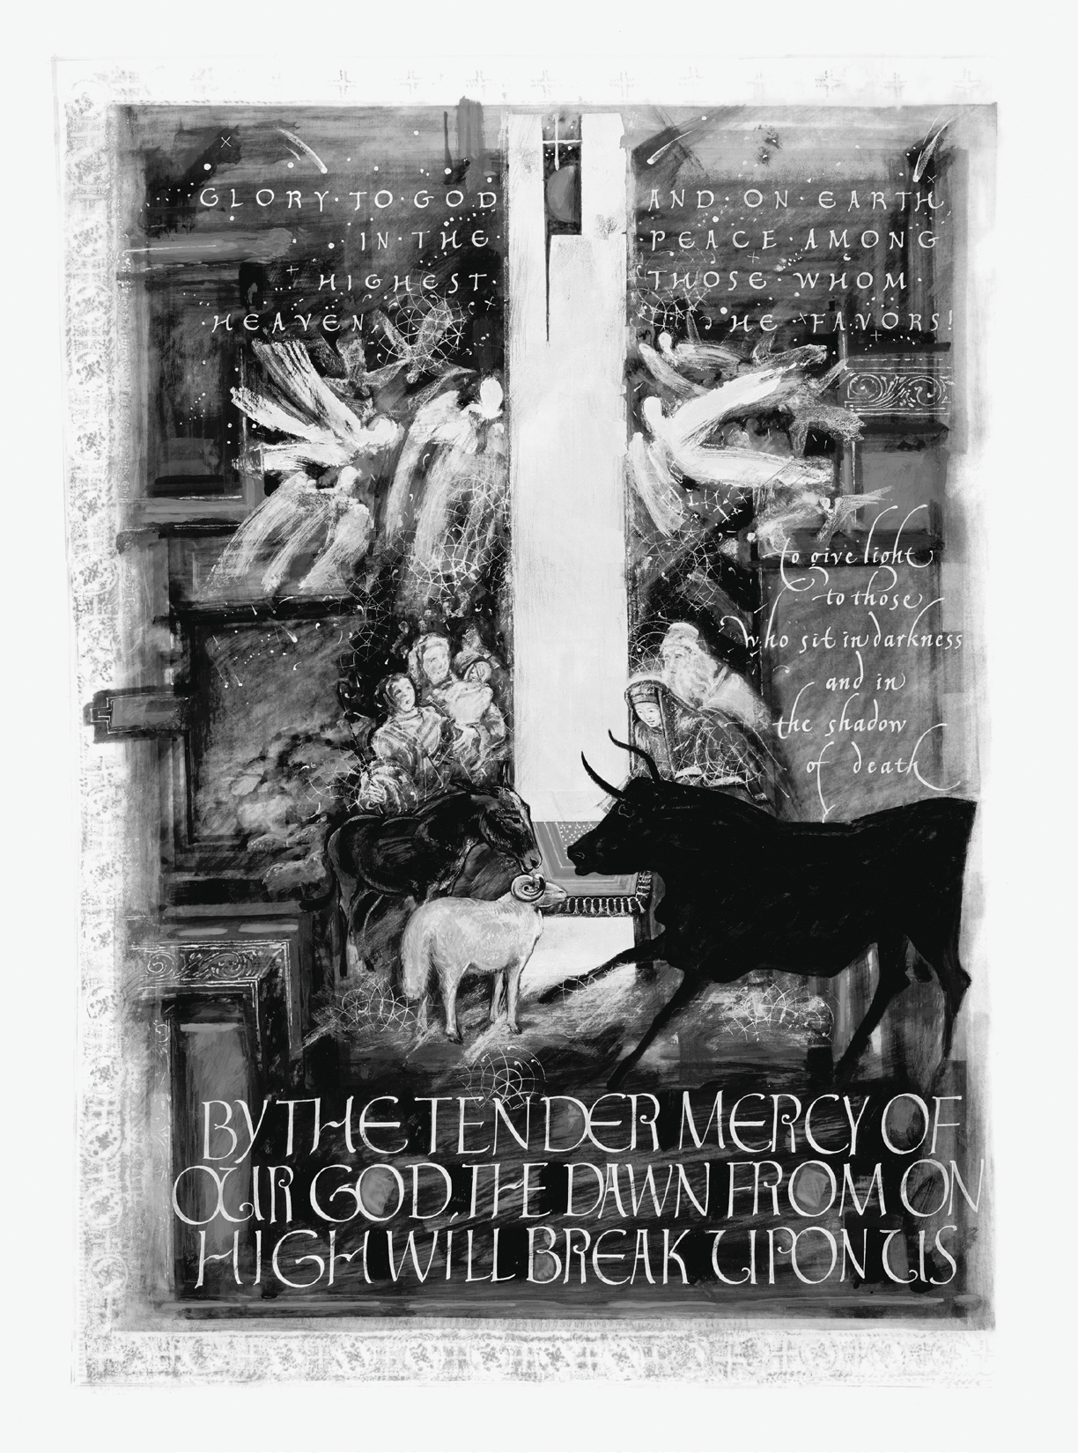

The FirsT sunday aFTer ChrisTmas

# holy euCharisT

deCember 31, 2023 aT 11:00 am

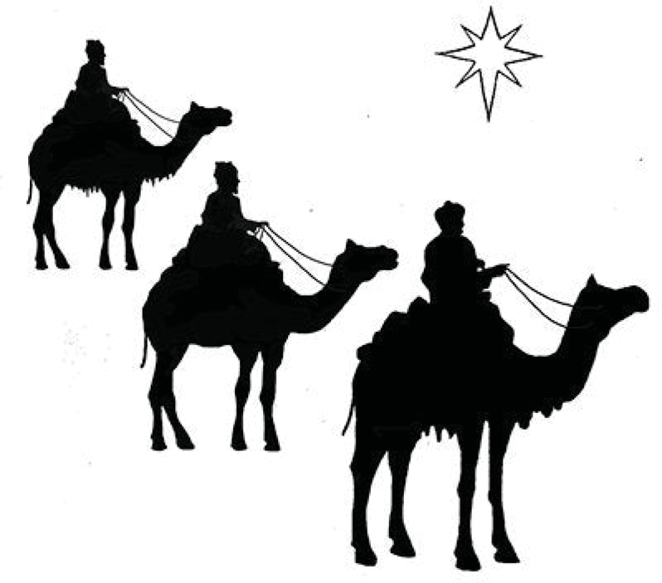

FeastoftheEp phany

**Saturday | January 6 | 7:30 pm | Church**

Fr dayIJanuary6I7:30pm IChurch

Everyyear, 2daysafterChristmas,theEpiphanyFamilygathersforaparty.Wecelebratethea**r**iva oftheWise2enwithaFestiveEucharist.5nthe6nglicanTradition,thisistheo**f**icialendo Christmastide,butitalsohasd **e**permeanings,withitsownshortseasonthatmarkstheBaptism ofOurLordandtheWe **d**ingofCana.

Whytheseevents=>owaretheco **n**ectedtoChristmas=Theanswerliesinthemeaningoftheword "epiphany -itisamomentofsu **d**enrevelationorinsight,andthroughtheseevents,wehonorthe momentsintheJesusstorywhenGodmadeGodselfknowntoGod'speople.TheFeastofthe EpiphanycelebratestherevelationofGodincarnateasJesusChrist.

Furingthisservice,wewi**l**alsobeble**s**ingchalkforyoutotakehometomarkanothergreat6nglican traditionGChalkingoftheF **o**rs.Thisisawaytocelebrateandlitera**l**ymarkthisfeastwithchalkon ourfrontd **o**rs,askingforGod'sble**s**ingonourlivesandhome.

Thisisoureponymousfeastasacommunity,sowefo**l**owtheFestiveEucharistwithafestiveparty Weaskyoutohelpusmakethiscelebrationasu**c**e**s**bygivingourhospitalityteam ahand.Please contactAmandaEapatAmanda@ep phanyseae o gtoinquireaboutourhelpingbybringingf**o**d orlendingahelpinghandbefore,during,oraftertheevent.

FeastoftheEpiphanyisourfamilyreunion.Wehopeyoucome.

Yourpresenceise**s**entialtothefestivities

Cover Art: *Birth of Christ,* Donald Jackson, Copyright 2002, *The Saint John’s Bible*, Saint John’s University, Collegeville, Minnesota USA.

Used by permission. All rights reserved.

*An induction loop is provided for the benefit of hearing aid users.*

*To use please switch your hearing aid to "T."*

### The GaTherinG

*We invite you to help create the experience of silence before our service.*

*Our hope is to calm our hearts as we prepare to enter into an intensity of shared presence. Thank you for turning off all electronic devices.*

##### WELCOME AND ANNOUNCEMENTS

*At the sound of the bell, all rise as able.*

**HYMN 93: *Angels, from the realms of glory*** *Regent Square*

 

1

2

3

4

 

 

œ

~~œ~~

œ

œ

the the your the

œ

realms field con -

al -

œ

~~œ~~

œ œ

☺

œ

~~œ~~ ~~œ~~

~~œ~~ ~~œ~~

An - gels, from Shep - herds in

of glo - ry, a - bid - ing,

tem - pla - tions;

wing your flight watch - ing o’er

o’er your

Sa - ges, leave Saints be - fore

tar bend - ing,

bright - er watch - ing

vi - sions long in

œ

œ

œ

œ

œ

~~˙~~

œ

œ œ

œ

œ œ

œ

œ

œ

☺

œ œ œ

œ



œœ

☺

œ

œ

œ

œ

all

flocks beam

the by

a -

earth; night, far:

ye, God seek

who with the

sang you great

cre -

is

De -

a -

now sire

tion’s re - of

sto -

sid -

na -

ry, ing; tions;

hope

 

œ

  œ

œ

œ

˙

œ

œ

œ

œ

œ œ

˙

œ



œœ

☺

œ  œ

œ

now pro - claim

œ œ

Mes the his

*Refrain*

œ

■ œ

œ œœ œ

☺

-

yon - der shines ye have seen

si - ah’s birth: in - fant Light: na - tal star: shall ap - pear:

come and wor - ship,

in his tem - ple

and

fear,

sud - den - ly

the

Lord,

de - scend - ing,

*Words*: James Montgomery ( 1771-1854)

  œ

 œ

œ

œœ œ

œ

œ œ

œ

œ

œ

œ

œ

˙

˙

œ œ œ œ

☺

  œ



œ

œ

œ œ

œ œ œ ˙

☺

come

and wor - ship,

☺

wor - ship Christ, the

new - born King.

 

œ

  œœ œ

☺

œ

œ

œ

œ œ œ

œ

œœ

œ

˙

*Music:* Henry Thomas Smart (1815-79)

*Presider* Blessed be God: Father, Son, and Holy Spirit.

***All* And blessed be God's kingdom, now and for ever. Amen.**

*Presider* Almighty God, unto whom all hearts are open, all desires known, and from whom no secrets are hid: Cleanse the thoughts of our hearts by the inspiration of thy Holy Spirit, that we may perfectly love thee, and worthily magnify thy holy Name; through Christ our Lord. **Amen.**

**GLORIA** *sung by all Healey Willan*

Glo- ry be to God on high, and on earth peace, good will to all. We praise thee,



&

##

œ œ œ œ

œ

œ

˙

œ œ œ

œ ˙

œ

˙

#œ ˙

Œ

œ

˙

˙

we bless thee, we wor



&

## Œ

œ

˙

˙

Œ

œ

œ

œ œ

œ

œ

œ

œ

˙

œ

˙

w

œ œ

- ship thee, we glo -

ri - fy

thee, we give

&

##

œ

œ œ

œ œ

œ

˙

˙

˙

˙

˙

˙

œ

œ œ œ

˙

w

˙

thanks to thee for thy great glo -

ry,

O Lord God, heav'n

- ly

King, God

the Fa - ther



&

##

˙

˙

˙

˙

˙

œ œ

˙

œ œ ˙

˙

˙

˙

˙

Ó

Ó

Al -

migh

- - -

ty.

O Lord, the on -

&

##

˙

˙

˙

œ

œ

œ

œ

œ

œ

˙

˙™

œ

w

˙

˙

˙

ly - be - got-ten

Son, Je -

sus Christ; O Lord God,

&

##

œ œ œ œ

œ œ

˙

˙™

œ

˙

˙

˙

˙

˙

˙

œ

œ

n˙

œ

œ

Lamb of God, Son of the Fa -

ther,

that ta - kest

a - way the sins of the



&

## w

˙

œ œ ˙

˙

˙

˙

œ

œ

˙

˙

˙

œ

œ

n˙

œ

œ

world, have mer - cy

up - on

us. Thou that ta - kest

a - way the sins of the

&

## w

˙

˙

˙

˙

w

œ

œ

˙

˙

œ œ

˙

˙

˙

world, re -

ceive

our prayer. Thou that sit

- test

at the right hand of

God the Fa -

&

##

˙

˙

˙

˙

˙

˙

˙

˙

˙

˙

˙

Ó

œ

œ

œ œ œ œ

ther, have mer - cy

up - on

us. For thou on -

ly art

ho -

&

##

œ ˙

#œ ˙

Œ

œ

œ œ nœ œ

w

˙ œ œ œ œ œ œ

˙

œ œ

ly;

thou on - ly

art the Lord; thou on -

ly,

O Christ, with the

#### 4



&

##

˙

˙

˙

˙

œ

œ œ œ

˙

˙ œ œ ˙

˙

˙

˙

˙

œ œ

Ho -

ly Ghost, art most high in the glo - ry

of God the

Fa -

&

## ˙

œ ˙

œ

œ Œ ˙

˙

˙

˙

˙

œ

œ ˙

™

œ œ œ œ w

w™

ther.

A - - - - - - -

men.

*Presider* The Lord be with you.

***All* And with thy spirit.**

*Presider* Let us pray.

**THE COLLECT OF THE DAY** *(said by all)*

***All* Almighty God, who hast poured upon us the new light of thine incarnate Word: Grant that the same light, enkindled in our hearts, may shine forth in our lives; through the same Jesus Christ our Lord, who liveth and reigneth with thee, in the unity of the Holy Spirit, one God, now and for ever. Amen.**

### The LiTurGy of The Word

*All are seated.*

**THE LESSON*: Isaiah 61:10-62:3***

I will greatly rejoice in the Lord, my whole being shall exult in my God; for he has clothed me with the garments of salva- tion, he has covered me with the robe of righteousness, as a bridegroom decks himself with a garland, and as a bride adorns herself with her jewels. For as the earth brings forth its shoots, and as a garden causes what is sown in it to spring up, so the Lord God will cause righteousness and praise to spring up before all the nations. For Zion’s sake I will not keep silent, and for Jerusalem’s sake I will not rest, until her vindication shines out like the dawn, and her salvation like a burn- ing torch. The nations shall see your vindication, and all the kings your glory; and you shall be called by a new name that the mouth of the Lord will give. You shall be a crown of beauty in the hand of the Lord, and a royal diadem in the hand of your God.e or asleep we may live with him. Therefore encourage one another and build up each other, as indeed you are doing.

*Lector* The Word of the Lord.

***All* Thanks be to God.**

#### 5

*The people stand as able and sing.*

**HYMN 105: *God rest you merry, gentlemen*** *God rest you merry*

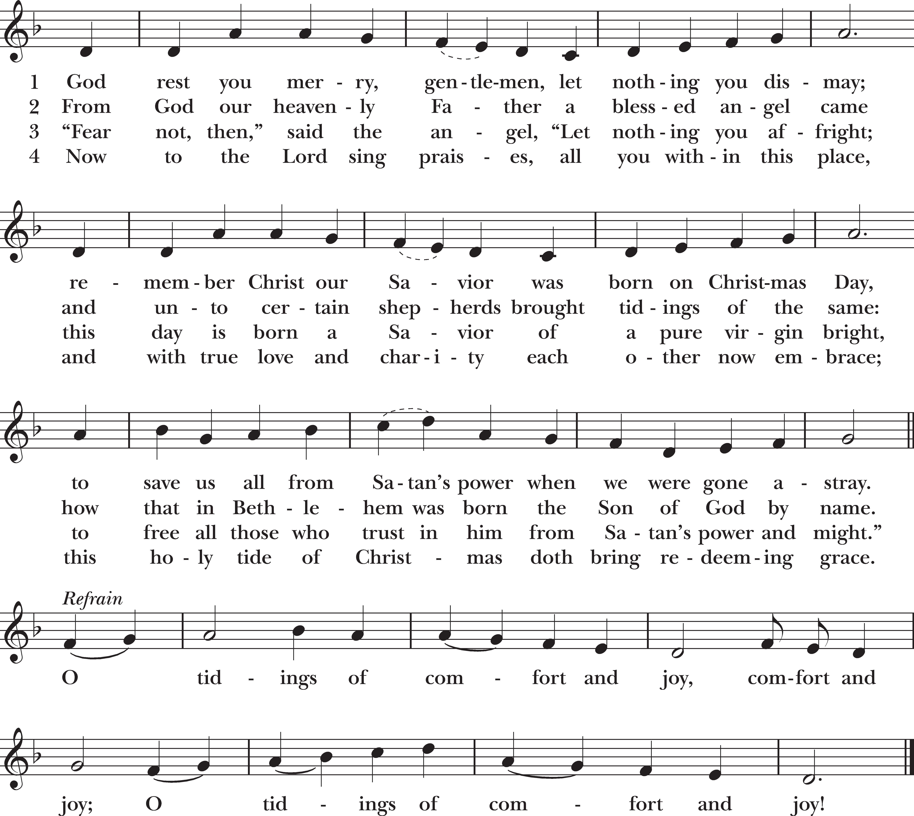

*Words*: London carol, 18th cent.

*Music:* melody from *Little Book of Christmas Carols*, ca. 1850

**THE GOSPEL: *John 1:1-18***

*Gospeler* The Holy Gospel of our Lord Jesus Christ according to John.

***All* Glory be to thee, O Lord.**

In the beginning was the Word, and the Word was with God, and the Word was God. He was in the beginning with God. All things came into being through him, and without him not one thing came into being. What has come into being in him was life, and the life was the light of all people. The light shines in the darkness, and the darkness did not overcome it.

There was a man sent from God, whose name was John. He came as a witness to testify to the light, so that all might believe through him. He himself was not the light, but he came to testify to the light. The true light, which enlightens everyone, was coming into the world.

He was in the world, and the world came into being through him; yet the world did not know him. He came to what was his own, and his own people did not accept him. But to all who received him, who believed in his name, he gave power to become children of God, who were born, not of blood or of the will of the flesh or of the will of man, but of God.

And the Word became flesh and lived among us, and we have seen his glory, the glory as of a father’s only son, full of grace and truth. (John testified to him and cried out, “This was he of whom I said, ‘He who comes after me ranks ahead of me because he was before me.’”) From his fullness we have all received, grace upon grace. The law indeed was given through Moses; grace and truth came through Jesus Christ. No one has ever seen God. It is God the only Son, who is close to the Father’s heart, who has made him known.”

*Gospeler* The Gospel of the Lord.

***All* Praise be to thee, O Christ.**

#### 6

**THE SERMON: *The Reverend Pam Tinsley***

*Reflective silence and stillness are kept after the sermon.*

***Sermon Notes***

*The people stand as able and sing.*

**THE CREED** *Divinum mysterium*

&bb 3 ˙

b 4

œ

˙

œ

˙

œ

˙

œ ˙™

˙

œ

˙

œ

1. We be - lieve
2. Christ, who on

|  |  |  |  |  |  |  |  |  |
| --- | --- | --- | --- | --- | --- | --- | --- | --- |
| in | God | the | Fa | - ther, | | God | al - might - y, | |
| the | cross | for - | sak | - en; | | he | des - cend - ed | |
| in | God | the Spi | | - | rit; | in | one Church, | be - |

1. We be - lieve



&bb

b

œ

œ

œ

˙™

˙

œ

˙

œ ˙

œ

˙

œ ˙™

by whose

plan

earth

and

heav -

en sprang to be -

ing,

to low,

the

a -

dead. bove:

We saints

be -

of

lieve God

in Je -

in one

sus com -

ri -

mun -

sen, ion,



&bb

b ˙

œ

˙

œ

œ

œ

œ

˙™

˙

œ

˙

œ

˙

œ

all

cre - a

- ted

things

be -

gan.

We be - lieve

in Christ

the

heav -

one

&bb

b

˙

œ

œ

œ

œ

˙™

˙

œ

˙

œ

˙

œ

˙™

en's in

king ho

to

- li -

rule ness

and and

reign, love.

to the

We shall

Fa -

rise

ther's with

side Christ

as -

is

|  |  |  |  |  |  |  |  |
| --- | --- | --- | --- | --- | --- | --- | --- |
| Sa | - - - vior, | Son | of | God | in | hu - | man form. |
| cend | - - - ed | till | as | judge | he | comes | a - gain. |
| glo | - - - ry | to | the | life | that | knows | no end. |

Ev -

&bb

b

˙

œ

˙

œ

˙

œ

˙™

˙™

er -

more

and ev -

er -

more.

*Words:* adapt. Zachary Hemenway (b.1983)

*Music:* Sanctus trope, 11th cent.

#### 7

*The people remain standing or kneel.*

##### THE PRAYERS OF THE PEOPLE

*Intercessor* As we wait in expectation for the day of the Lord, let us offer prayers to God for all in every danger and need.

*Cantor* Let us pray to the Lord.

*Sung by all at the conclusion of each petition.*

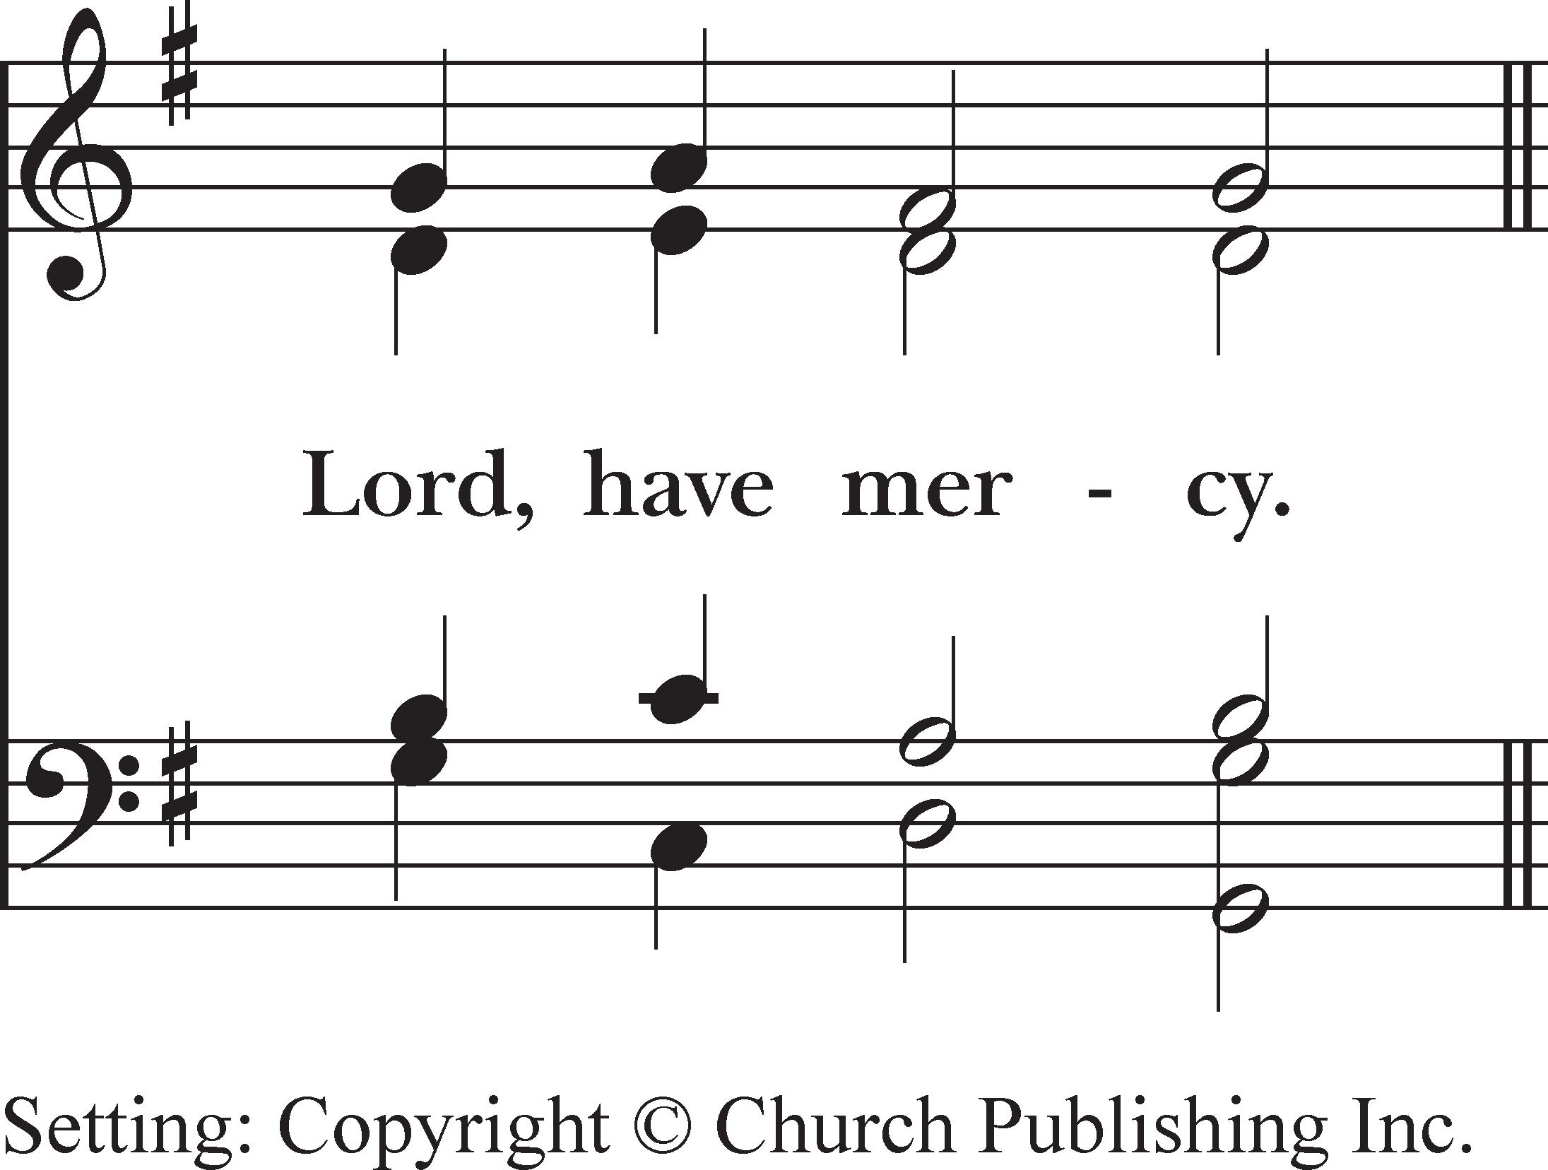

*Intercessor* Guide our leaders as they walk beside us, supporting us in our journey of faith. We pray for Michael, our Presiding Bishop, Melissa, our Bishop Provisional, our priests, and all who minister in your holy church. *(silence is kept)*

*Cantor* Let us pray to the Lord.

***All* Lord, have mercy.**

*Intercessor* Give those in authority an imagination and determination for peace between peoples, plenty for all, and justice for everyone, even those who are forgotten. We pray this morning especially for peace in Ukraine and in Israel/Palestine

. *(silence is kept)*

*Cantor* Let us pray to the Lord.

***All* Lord, have mercy.**

*Intercessor* Lead us to a place of wholeness and make each of us an agent of healing in the world. We pray for those close to us,

for those who have asked for our prayers today, and for those we now name silently or aloud. *(silence is kept)*

*Cantor* Let us pray to the Lord.

***All* Lord, have mercy.**

*Intercessor* We pray for those who are born today as well as those who are being welcomed home to your eternal kingdom. May

your will for all your children be fulfilled here on earth and in the life to come. *(silence is kept)*

*Cantor* Let us pray to the Lord.

***All* Lord, have mercy.**

*The Presider offers a concluding Collect.*

*Presider* Almighty God, who gave us salvation through Jesus Christ and made us children of light, hear the prayers we offer this day and bring us to the time and season of your glory; through Jesus Christ our Lord. **Amen.**

#### 8

*The Presider continues*

##### CONFESSION OF SIN

*Presider* Let us humbly confess our sins unto Almighty God.

*The people kneel as able.*

*Silence may be kept.*

***All* Most merciful God,**

**we confess that we have sinned against thee in thought, word, and deed,**

**by what we have done,**

**and by what we have left undone.**

**We have not loved thee with our whole heart; we have not loved our neighbors as ourselves. We are truly sorry and we humbly repent.**

**For the sake of thy Son Jesus Christ, have mercy on us and forgive us; that we may delight in thy will,**

**and walk in thy ways,**

**to the glory of thy Name. Amen.**

*Presider* Almighty God have mercy on you, forgive you all your sins through our Lord Jesus Christ, strengthen you in all goodness, and by the power of the Holy Spirit keep you in eternal life. **Amen.**

*The people stand.*

##### THE PEACE

*Presider* The peace of the Lord be always with you.

***All* And with thy spirit.**

*The ministers and people greet one another in the name of Christ.*

### The LiTurGy of The TabLe

##### OFFERTORY SENTENCE

*Presider* To us a child is born, to us a son is given; and he shall be called the Prince of Peace.



*The offertory is the time during the service when we give offerings to God, acknowledging that all we have comes from God. The choir offers their gift of music, and this is our opportunity to offer thanks to God through a monetary gift to support the ministries of Epiphany. Active Epiphany parishioners make an annual pledge commitment toward the vitality of our ministries. In some cases pledging parishioners also make a financial contribution at the offertory. Money placed in the hunger basket at Communion supports our outreach ministry of feeding those in need. You may use the QR code, either during the anthem or later at your convenience, or place your offering in the offering plate as it is passed.*

#### 9

**OFFERTORY ANTHEM**: ***Jauchzet Gott in allen Landen from Cantata no. 51, BWV 51*** *J. S. Bach (1685-1750)*

Raise a shout to God in all lands. All created things that heaven And earth contains

Must exalt his glory;

With the angels let us today

Sing a song of acclamation to our God,

Because he has stood with us

In our envy and pity at all times.

*(Sung in German)*

*The people stand as the thurifer comes to the top of the chancel steps. The thurifer bows to the people and the people bow to the thurifer. The thurifer censes the people, and then all bow again.*

*The people remain standing.*

##### EUCHARISTIC PRAYER II

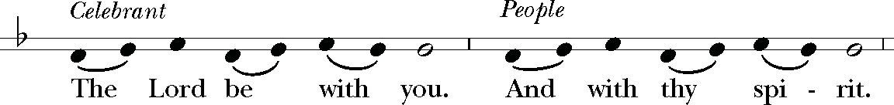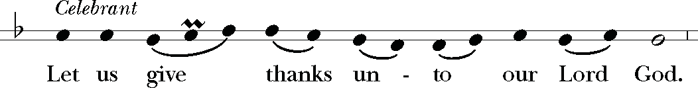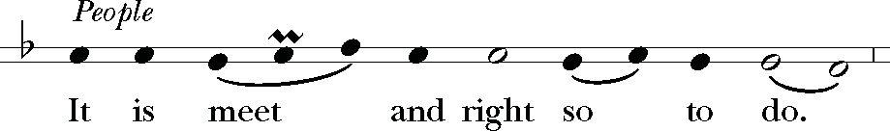

*The Presider continues*

It is very meet, right, and our bounden duty, that we should at all times, and in all places, give thanks unto thee, O Lord, holy, almighty, everlasting God, because thou didst give Jesus Christ, thine only Son, to be born for us; who, by the mighty power of the Holy Ghost, was made very Man of the substance of the Virgin Mary his mother; that we might be delivered from the bondage of sin, and receive power to become thy children.Therefore with Angels and Archangels, and with all the company of heaven, we laud and magnify thy glorious Name; evermore praising thee, and singing:

#### 10

**SANCTUS** *sung by all Willan*

Ho - ly,

  ˙

˙

˙

˙

˙

˙

œ œ ˙

⬥

˙

œ œ

ho - ly,

ho -

ly,

Lord God of

Hosts:

 

⬥

œ œ ˙

œ œ ˙

œ œ œ œ ˙ ˙

˙ ˙

Hea - ven and

earth are full

of thy

glo - ry.

Glo -

ry be to



  œ œ œ œ œ œ œ œ

⬥

œ œ ˙

œ œ œ œ

˙ ˙

thee, O Lord Most

High.

Bless - ed

is he that

com - eth

in the

  œ œ œ œ

˙ ˙ œ œ

˙ ˙

œ œ ˙

œ œ œ ˙

⬥

name of the

Lord. Ho -

san - na

in the high -

est.

All glory be to thee, O Lord our God, for that thou didst create heaven and earth, and didst make us in thine own image; and, of thy tender mercy, didst give thine only Son Jesus Christ to take our nature upon him, and to suffer death upon the cross for our redemption. He made there a full and perfect sacrifice for the whole world; and did institute, and in his holy Gospel command us to continue, a perpetual memory of that his precious death and sacrifice, until his coming again.

For in the night in which he was betrayed, he took bread; and when he had given thanks to thee, he broke it, and gave it to his disciples, saying, “Take, eat, this is my Body, which is given for you. Do this in remembrance of me.”

Likewise, after supper, he took the cup; and when he had given thanks, he gave it to them, saying, “Drink this, all of you; for this is my Blood of the New Covenant, which is shed for you, and for all, for the remission of sins. Do this, as oft as ye shall drink it, in remembrance of me.”

Wherefore, O Lord and heavenly Father, we thy people do celebrate and make, with these thy holy gifts which we now offer unto thee, the memorial thy Son hath commanded us to make; having in remembrance his life, blessed passion, and precious death, his mighty resurrection and glorious ascension; and looking for his coming again with power and great glory.

And we most humbly beseech thee, O merciful God, to hear us, and, with thy Word and Holy Spirit, to bless and sanctify these gifts of bread and wine, that they may be unto us the Body and Blood of thy dearly-beloved Son Jesus Christ.

And we earnestly desire thy goodness to accept this our sacrifice of praise and thanksgiving, whereby we offer and present unto thee, O Lord, our selves, our souls and bodies. Grant, we beseech thee, that all who partake of this Holy Communion may worthily receive the most precious Body and Blood of thy Son Jesus Christ, and be filled with thy grace and heavenly benediction; and also that we and all thy whole Church may be made one body with him, that he may dwell in us, and we in him; through the same Jesus Christ our Lord;

By whom, and with whom, and in whom, in the unity of the Holy Ghost all honor and glory be unto thee, O God Almighty, world without end. **AMEN.**

#### 11

And now, as our Savior Christ hath taught us, we are bold to pray,

**THE LORD’S PRAYER** *sung by all*



&bb œ œ œ

˙

œ

œ œ ˙

˙

œ œ œ œ œ œ œ œ ˙

œ

œ

œ ˙

˙

Our Fa- ther,

who art in hea - ven,

hal - low - ed

be thy Name, thy king-dom come,

&bb

œ œ œ ˙ ˙ œ œ œ œ œ œ œ œ œ œ ˙ œ œ œ œ œ œ œ ˙ ˙

thy will be done, on earth as it is in hea - ven.

Give us this day our dai - ly

bread.

&bb

œ œ œ œ œ œ œ ˙ œ œ œ œ œ œ œ œ œ ˙ ˙

And for - give

us our tres - pas - ses,

as we for - give those who tres-pass

a - gainst

us.

&bb

œ œ œ œ œ œ œ œ œ ˙ œ œ œ œ œ œ œ œ ˙ œ œ œ œ œ ˙

And lead us not in - to temp-ta -

tion,

but de - li - ver us from e -

vil.

For thine is the king- dom,

&bb œ

œ

œ

œ

œ

œ

œ ˙

œ

œ

œ

œ

œ

œ

˙

œ

˙

˙

and the power, and the glo -

ry,

for ev - er

and ev -

er.

A - men.

##### BREAKING OF THE BREAD

*The Presider breaks the consecrated Bread. A period of silence is kept.*

**FRACTION ANTHEM*: Jesus*, *Lamb of God*** *Franz Schubert*

##   œ

œ œ œ

œ œ œ

œ œ œ

# œ œ œ

œ œ ‰

☺ œ œ☺

œ œ œ☺ œ œ☺ œ

œ œ

Je - sus, Lamb of

œ

God: have mer - cy on

us.

##  œ

œœ œ

œœ

œ œ

œœ

œ œ œ

œ œ ☺œ

œ œ ‰

##   œ

☺

☺

œ œ

œ œ

œ œ œ

œ œ œ

# œ œ œ

œ œ ‰

☺ œ œ☺ œ œ☺ œ œ☺ œ

☺

☺

œ☺ œ

œ œ

Je - sus, bear - er of our sins: have

  œ œœ œ œœ

☺

☺

☺

œ

œ

œœ œ

☺

œœ

☺

œ œ œœ œ œ œ

☺

  œ œ œ œ

œ œ

☺

œ œ œ œ œ œ

☺

Je - sus,

re - deem - er, re - deem - er of

☺

☺ œœ

œ

world:

œ

œ ‰

œ

‰

  œ

œ

œœ

☺

œ

œ œœ œ

☺

œœ œ

☺ œ

the

 ☺œ

œ œ ‰

mer - cy on

us.

#### 12



  œ œ œ œ œ œ ‰ œ œ œ œ œ œ

☺

œ

œ

‰

∑

∑

give

 œ

us your peace,

☺

give us your peace.

œ œœ☺

œ œ ‰ œ œ œ œ œ œœ

☺

œ  œ

‰

∑

∑

##### THE INVITATION TO COMMUNION

*Presider* The Gifts of God for the People of God. Take them in remembrance that Christ died for you, and feed on him

in your hearts by faith, with thanksgiving.

*All are invited to receive the Holy Communion. It is your choice as to whether you receive Holy Communion or a blessing. You may receive Communion or a blessing at the standing station in the front of the nave or proceed to the altar rail. The bread will be placed in your palm. You may consume the bread and then drink from the chalice (please grasp the bottom of the chalice firmly and guide it to your lips); or, you may leave the bread in your palm for the chalice bearer to dip it into the wine and place it on your tongue. Self-intinction is strongly discouraged by the Episcopal church. The people’s response to receiving the bread and the wine is “Amen.” Gluten-free wafers are available. To indicate to the Eucharistic minister that you would like a gluten-free wafer, please present your hands palms down. Those who do not wish to receive Communion are invited to come forward for a blessing, indicated by crossing your arms over your chest.*

##### MUSIC AT COMMUNION

***Höchster, mache deine Güte from Cantata no. 51, BWV 51*** *Johann Sebastian Bach (1685-1750)*

Most High, render your goodness,

also with our government, new.

Thus, for the faithfulness of God the Father,

A thankful disposition, too, Should show, through a pious life, That we are called your children.

*(Sung in German) The people stand as able.*

##### POSTCOMMUNION PRAYER

*Presider* Let us pray.

***All* Eternal God, heavenly Father, who hast graciously accepted us as living members of thy Son Jesus Christ our Lord, and fed us with spiritual food in the Sacrament of his Body and Blood: Send us now into the world in peace, and grant us strength and courage to love and serve thee with gladness and singleness of heart; through the same Christ our Lord. Amen.**

##### THE BLESSING

*Presider* May Almighty God, who sent his Son to take our nature upon him, bless you in this holy season, scatter the

darkness of sin, and brighten your heart with the light of his holiness. Amen.

May God, who sent his angels to proclaim the good news of the Savior’s birth, fill you with joy, and make you heralds of the Gospel. **Amen.**

May God, who in the Word made flesh joined heaven to earth and earth to heaven, give you his peace and

favor. **Amen.**

And the blessing of God Almighty, the Father, the Son, and the Holy Spirit, be upon you and remain with you

for ever. **Amen.**

**HYMN 100*: Joy to the world! the Lord is come*** *Antioch*

ceive her

  œ

œ

☺

œ

1. Joy to
2. Joy to

*3 No more

 œ

œ☺ 





the the let

the

œ

œ

œ

world! world! sins world

☺

the

the and

œ

œ

œ

Lord is Sa - vior

œ



œ

œ

come: reigns; grow, grace,

œ

☺

let let nor

œ

œ

earth us thorns makes

~~œ~~

☺

re - our in -

œ

4 He rules

with



sor - rows truth and

  œ œœ

œ

œ œ



and

~~œ~~☺

the

~~œ~~

☺

œœ

☺

œ œ œ œ œ œ œ œœ

œ☺

☺

☺ ☺

œ œ œ œ

œ œ œ œ

☺ ☺

King;

let

ev -

ery

heart

pre - pare

him

room,

and

songs em -

ploy,

while fields

and

floods,

rocks,

hills

and

plains,

re -

fest

the

ground; he

comes to

make

his

bless - ings

flow

far

na - tions

  œ œ

☺

œ

œ œ☺

œ

œ

œ

heaven and na - ture

œ

œ

sing, joy, found,

œ

œ

œ

œ œ

œ

œ

œ œ ‰

œ

☺

œ œ œ œ

☺ ☺

œ☺

œ œ

and re far

œ œ

œ

 

‰

œ

heaven and

☺

œ œ œ œ

☺ ☺

na - ture

peat the sound - ing

- peat the sound - ing

as the curse is as the curse is

won - ders of his his

 

Œ

‰

œœ

love,

☺

œœ

☺

œœ œœ œœ

and

☺ ☺ ☺

won - ders of

˙œ

☺

prove

the

glo -

ries of

his

right - eous -

ness,

and

1. and

heaven and

na -

ture

sing,

and

1. re -

peat

the

sound - ing

joy,

re -

1. far

as the

curse is

found,

far

1. and

won - ders of

his

love,

and

#### 14

heaven



  œ

sing, joy, found, love,

œ œ

and re far

œ œ œ

☺

œ œœ œ

heaven, and

☺

heaven and

☺ ☺

- peat, re - peat

as, far as

the the

and

 œœ

☺

œ

☺

œ

☺ ☺

œœ

won - ders,

œ œ œ

 

won - ders



☺

œ

œ

œ☺

œ œ

na - ture sound - ing curse is

of his

œ œ œ

˙

sing. joy. found. love.

˙

and

na - ture

sing,

peat

the sound - ing

joy,

as the curse is found,

won - ders of

his

love,

*Words*: Isaac Watts (1674-1748)

*Music:* George Frideric Handel (1685-1759)

##### DISMISSAL

*Minister* Let us bless the Lord.

***All* Thanks be to God.**

*After the procession has led the way out of the church, we invite you to remain for the Voluntary or depart quietly.*

##### VOLUNTARY

Music reprinted by permission, OneLicence #A-706859

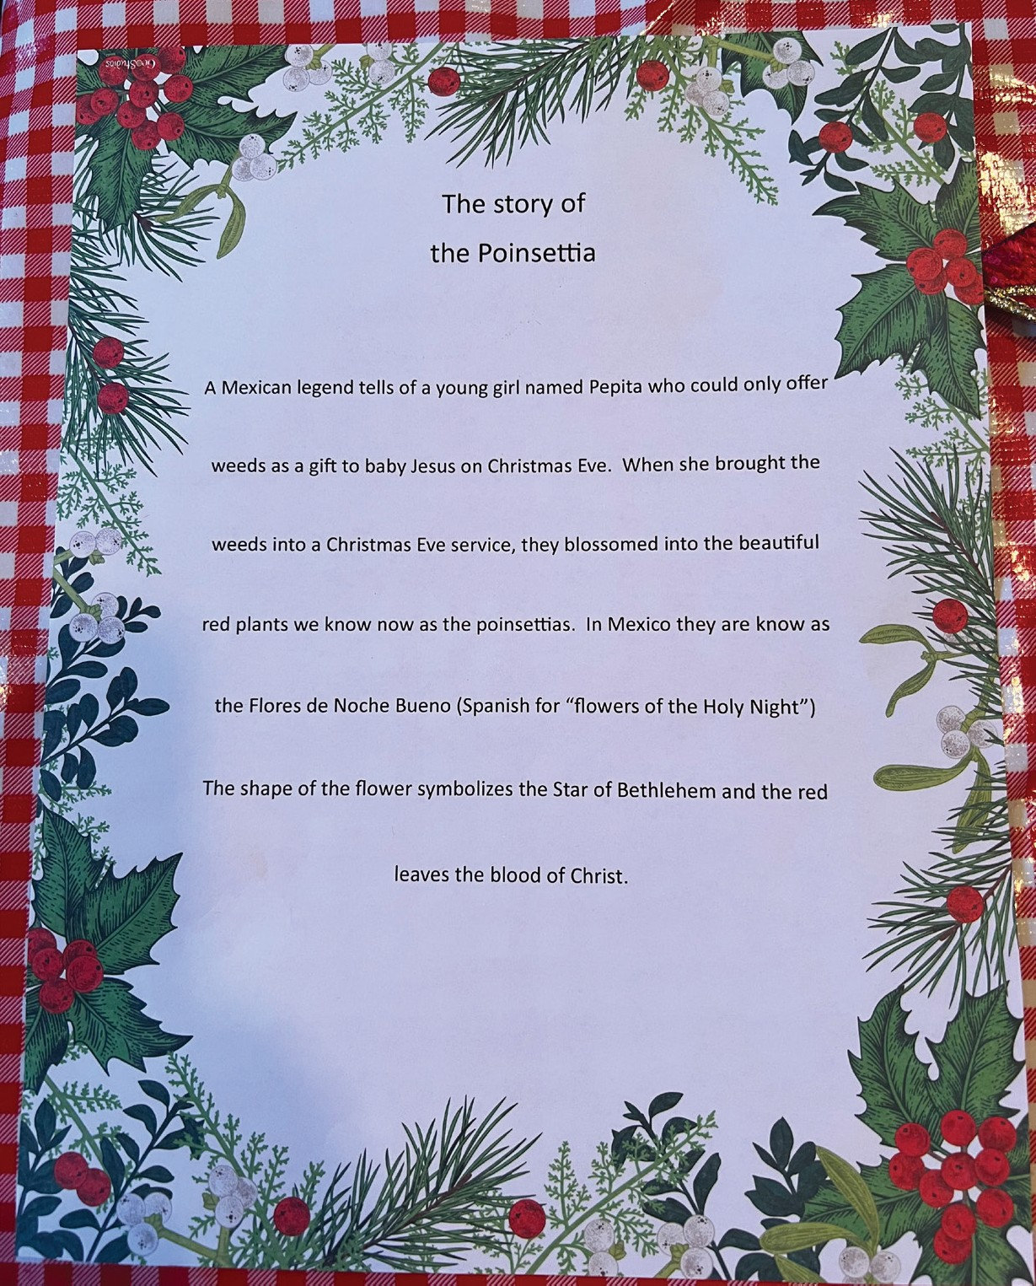**Please give a poinsettia a new home!**

#### We need to have all of our red poin- settias removed this week. Please take one to enjoy, or share one with a friend or loved one.

***Offerings at Epiphany***

**Adult Formation | Sundays (except First Sundays, when there is a brunch) | 10:00 am | Great Hall**

Join others for an hour of learning. Topics vary each week from spiritual formation, human interest, current affairs, and

more. *No forum December 31.*

**Choral Evensong | Sundays | 5:30–6:30 pm | Church and YouTube**

Sung at the close of day in cathedrals and churches throughout the world, Choral Evensong is a service of Evening Prayer, derived from the ancient offices of Vespers and Compline. The choir sings the traditional evening prayers of the church that have been offered for centuries, while the congregation listens, joins in the hymns, and adds their own prayers to those of the choir*. No Evensong December 31.*

**Yoga at Epiphany | First and Third Wednesdays | 9:00–10:00 am | Great Hall**

We invite you to join a free yoga class with an all-levels approach led by Michael Glass every first and last Wednesday of the month. For more information please contact Amanda at [***amanda@epiphanyseattle.org.***](mailto:amanda@epiphanyseattle.org)

**C. S. Lewis Minyan | Thursdays | 8:40–9:40 am | Christie House Library and Zoom**

*Jonathan Roberts*

The C. S. Lewis minyan is reading *The Lion, the Witch, and the Wardrobe*. This minyan meets in person and online. If you would like to be on the email distribution list and receive notes each week or you would like the Zoom link please email Jonathan Roberts at [***Jonro@rprime.com****.*](mailto:Jonro@rprime.com)

**All Threads Together | Thursdays | 10:00–noon | Christie House Library**

Bring your latest needle craft project to our weekly meetings of fellowship and fun. We work on individual projects as well as prayer shawls and hats for local ministries. All are welcome!

**Zoom Bible Study | Thursdays | 11:00–noon | Zoom**

Join other parishioners from Epiphany and parishioners from St. John’s in Essex, Connecticut, for a Zoom-only study class on the Bible. This class will look in depth at some of the stories from the previous week’s reading from the *Year in the Bible*. Please contact Lisa Ozaeta at [***lisa@epiphanyseattle.org***](mailto:lisa@epiphanyseattle.org)for information and the Zoom link*.*

**Bible Study | Fridays | 10:30–11:30 am | Great Hall and Zoom**

*The Rev. Doyt Conn, Jr.*

The Bible is the core document that defines the framework in which followers of Jesus live. And so, this class is not just about becoming familiar with the Bible, it is about unpacking it and pulling it apart and seeking out links and allusions and associations between different parts of the Bible. This Bible study is a journey into words and meaning and characters and the context behind them. We will be looking at stories that align with our *Year in the Bible* readings. Come be part of this biblical quest of Christian meaning, understanding, and relevance with the Rev. Doyt Conn. All are welcome. Contact Diane Carlisle at [***dcarlisle@epiphanyseattle.org***](mailto:dcarlisle@epiphanyseattle.org)for information and the Zoom link*.*

***Serving this day***

*Rector* The Reverend Doyt L. Conn, Jr.

*Associate Priest* The Reverend Pam Tinsley *Assistant Director of Music* Julian Petrallia *Soloist* Emily Herivel

*Verger* Tom Rohm

*Lector* Frank Lawler

*Eucharistic Minister* Vince Booth

*Thurifer* Sabrina Reyes

*Ushers* Dawn Friend

*Parish Life Minister* Amanda Eap

*Flowers* Alice Foreman

*Altar Guild* Sandra Darling



**Readings for the Week of December 31**–**January 6**

|  |  |  |
| --- | --- | --- |
| 12/31 | Isaiah | 13-17 |
|  | Psalm 112 |  |
| 1/1 | Judges | 18-22 |
|  | Psalm 113 |  |
| 1/2 | Judges | 23-27 |
|  | Psalm 114 |  |
| 1/3 | Judges | 28-30 |
|  | Psalm 115 |  |
| 1/4 | Judges | 31-35 |
|  | Psalm 116 |  |
| 1/5 | Judges | 36-38 |
|  | Psalm 117 |  |
| 1/6 | Ruth  Psalm 118 | 39-41 |

**PARISH PRAYER LIST**

**WE PRAY FOR THOSE WHOSE BIRTHDAYS FALL BETWEEN DECEMBER 31 AND JANUARY 6**

Katarina Kueber, Nancy Emerson, Meredith Richards Lippman, Genevieve Potts, Margie Kates, John Robinson, Ira Williamson, David Williams, Kjristine Lund, Haley Ozaeta, Eleanor Nelson, Benjamin Graves, William Hurt, Mackenna Ward

**WE PRAY FOR THOSE ON THE DIOCESAN CYCLE OF PRAYER**

All Saints’, Vancouver St. Anne’s, Washougal

**WE PRAY FOR THOSE IN OUR PARISH WHO ARE ILL OR GRIEVING**

Cheryl Morgan, Eileen Riley, Marylyn Vincent, The Osterlind Family, Steve, Lynn Manley, Alice Foreman, Thomas, John Kirkpatrick, Barbara Lock, Melanie Hodgman,

Amber Gregory, Dennis Hogan, Trudy Baldwin, Jessica Khan, Mary Jane Anderson, Arthur Sullivan, Rose Chimo, Linda Baker, Bill Hess, Jane Hess, Barbara Beck, Jeremy Bacon, Miah, Janet Salisbury, Pete Melin, Norma Lorenzana,

Bill Ingham, Sherry Braak, Cooper Sayer, Kathleen Balducci, Tommy Carlisle, Bill Rex, Lisa Robertson, Ava Hall, Diane, Mary Magee, Ruth Hurt, William

Are you or a loved one in need of some extra, tender loving care? Pastoral Care Ministries at Epiphany can reach out through a written prayer, a Eucharistic visit, a phone call, a greeting card, a bouquet of Epiphany flowers, a prayer shawl, and/or a meal delivered. Please contact Diane Carlisle at [***verger@epiphanyseattle.org***](mailto:verger@epiphanyseattle.org)

VestryCandidates'Biographies

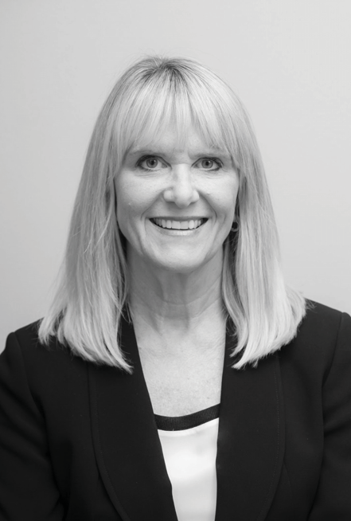 n y isaIife-IongEpiscopaIianandwasbapti)edinthefaithas aninfantatafamiIyceremonywithhercousinsinLosAngeIes.In1968, she moved from Denverto Be**I**evue with herfamiIy and a**t**ended St. ThomasEpiscopaIMedina.Wendywenttoco**I**egeatUCLA whereshe joinedA**I**SaintsBeverIyHi**I**s.In1986,shemovedbacktoSea**t**Ietoearn herMBAatUW.SheandherhusbandSteveraisedtwodaughters,TayIor and Spencer,and were members ofSt.Stephens LaureIhurst.Wendy co-chaired the SundaySch **o**I,waspartofAItarGuiIdandchairedthe FinanceCommi**te**.WendyandStevemovedtoEpiphanyParishin2015. Shewasthri**I**edtojointhisdynamiccommunityofpeopIe.Sheispartofthe T**e**nF **e**dcrew,ushersa **t**he **1**am service,isTreasurerfortheService& 0utreachcommi**te**,andisonthePew Torchministry.Sheishonoredto beaskedtobeontheVestryandI**o**ksforwardtoservingtheParishinthis

faith-fi**I**ed way.0utside ofEpiphany,Wendy is a VP fora Swi**s**-based firm andI**o**ksforwardto semi-retirementin2024topursueherIongIistof ToDos incIudingweIcomingherfirstgrandchiId.

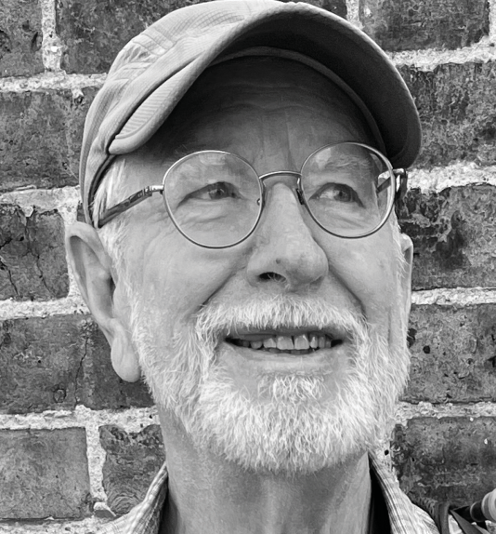JohnCarywasborninSea**t**Ie,raisedinSpokane,and aftersch **o**Ioutofstate and a job on CapitoIHi**I**, returnedtoSea**t**Iein197\andbeganpracticingIaw. Sue and John have Iived in the Mount Baker neighborh **o**dsince1974.TheyhavetwochiIdrenand fourgrandchiIdren,ranginginagefrom 5to15,inwhom they take greatdeIight.WhiIe Sue and John have traveIedoverseasextensiveIy,Theyespecia**I**yenjoythe waterandmountainsofthePacific_orthwest-hiking, camping,sk**i**ng andsaiIing.

Sue`acradIeEpiscopaIianaandJohnjoinedEpiphany about1980whentheirkidswerea **t**heageto Iearnthe truemeaningofChristmasandEaster.Hehasservedin anumberofroIesat Epiphany,incIudingtheVestry, searchcommi**te**s,andhostfor0vernightWatch,but the most substantiaI was nearIy 20 years as Chance**I**or,thechurch'sIawyer.

Sue and John participate enthusiastica**I**y in Epiphany'spiIgrimages,begi**n**ingwiththeHoIyLand to waIking the PiIgrim's Way to Canterbury this

summer.TheyIovetheMusicProgram and a**t**endasmanymusicaIeventsasTheycan.Thissummer theybecamechoirgroupiesand fo**I**owedthem toservicesatSt.PauI sandDurham CathedraIs. EpiphanyhasbecomeoneofthecenterpointsoftheirIivesandtheirhomecommunity.

Johnhasb **e**nespecia**I**ydrawntoDoyt'steachingandhasparticipatedintheMinyanfrom itsbegi**n**ing andinasmanyforumsandcIa**s**esashecan.Heisnowapartofthecrewundertaking toreadtheBibIe inaYear.TakingtoheartDoyt'sinjunctiontopraytheHourbyHourservices,hebeIongstotheMarco PoIogroupthatreadsdaiIyIe**s**ons.HegrewupinanonIiturgicaIchurch-Presbyterian-butwasdrawn totheEpiscopaIianserviceatSt.JohntheDivineduring graduatesch **o**I.AtEpiphanyJohnhascometo ana **p**reciationoftherichne**s**oftheIiturgyand how itco **n**ectsuswithoursouIs.Epiphanyhas becomemyspirituaIhome.HewouIdbegreatIyhonoredtoserveEpiphanyasamemberoftheVestry.

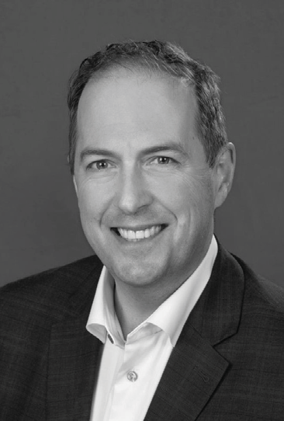 !, 7!BMR !wasbornandraisedinPasadena,CaIifornia.Aftergraduating from co**I**ege in the Pacific Northwest,he Iived inBoston,SanFrancisco,and Manha**t**anbeforese**t**IinginSea**t**Iewithhisbridein2 **0**$.DespiteanincIinationto continueaperipateticIifestyIe,oncechiIdrencameanda**t**endantfriendshipgroups formed,Sea**t**IewasquickIyd **e**medtheperfectpIacetoraiseafamiIy **-**George andhiswife,-ean,havetwochiIdren George/**1**2andGreta/132**.**Growingup, Georgea**t**endedA**I**SaintsChurch/ofPasadena,notBeverIyHi**I**s2andwasa

unioracoIyteforanumberofyears.Churcha**t**endancevanishedinco**I**ege,but wasreinvigorateda **t**hestu **n**ingIybeautifuITrinityChurchinBostonthentheIoveIy EpiscopaIChurchofSt.MarytheVirgininSanFrancisco.Churcha**t**endanceagain fe**I**bythewaysideinNew YorkCity,butuponmovingtoSea**t**Ie,GeorgequickIy beganauditioningEpiscopaIchurches.HethinkshetriednearIyeveryoneintown

/butcuriousIynotEpiphany2and usthadn tfoundhishomewhenhisfriend,AIex PoIson s,funeraIwasheIdatEpiphanyin2021 **-**DoytpresidedoverabeautifuIserviceandtherestis history.He sscarceIymi**s**edaSundaysince.GeorgeservesontheBoardoftheCo**I**egeCIubSea**t**Ie andworksintheequipmentIeasingindustryasthePacificNorthwestsaIesmanagerforCSILeasing.

7?!@?!?A?C!DEIivesinLeschi,andEpiphanyhasb **e**nher neighborh **o**dchurchfor12years.Shewasdrawnbytwo invitations on thewebsite 12"Ghereveryouareonyour spirituaI ourney you have a pIace at Epiphany." Inderstanding. espectfuI.Intriguing. **2**Therewasguided meditation ono**f**er.ThisIknow how todo.Doytaskedat theirfirstmeeting,"GhatareyouI**o**kingfor?"Ah,aserious priest.This ain tbean bag.Sheunderst**o**dtheBu **d**hist framework she knew the experience of equanimity o**c**asioned by practice. She said, "I mi**s** devotion, beIonging, Iove. I am f**e**Iing pu**I**ed here,butIdon t understand the Christian construct,the story.Are there practices?"Oh,Lamb.Sincethen,BarbarahastakenaImost every cIa**s** on o**f**erand taughta few-on Mysticism, ThomasMerton,GeorgeHerbert,St.PauI,Noah,CIimate Change.The day ob p **e**ks through on o**c**asion.She s taughtSundaySch **o**I,deIiveredahomiIy,constructedTaiQe aItars,Iectored,IadIed soup,poIished bra**s**,and heIped

design,write,andproduceanewwebsite.There sthat obagain.Sheisd **e**pIygratefuIforthebeautyof Epiphany s interiorspaces,its gardens,its music.Forfriendships thatendure.Forbeingca**I**edto a**c**ount.T**o**,fortheinte**I**igenceofitssermons,thereIiabIesurprisesinitsw **e**kIyIiturgy,thechiropractic mentaIad ustmenta**f**ordedhereachw **e**kasshegatherswithtwoormoreofyouandheIpsconstitute thebodyofChrist.SheispIacingherbetsonDoyt sbeIieftha **t**heneighborh **o**dchurchisthehopeof theworId,becauseshehasexperiencedthehopeand oythatcomesfrom d **e**pco **n**ectionovertime andsustainedpersonaIchangeforthebe**t**er.Atpresent,BarbaraisareguIara**t**end **e**ofthe ector s BibIeStudy,Evensong,andthe **1** **0**a.m.SundayEucharist.SheisatoncehonoredandhumbIedby theinvitationtoserveontheVestryofEpiphanyParish.S **e**,thatwasn tsohard couIdhaveb **e**nworse. Yougrow.

#### Parish Staff

The Rev. Doyt L. Conn, Jr. *Rector*

Jad Baaklini *Director of Communications*

Karen Berry *Parish Administrator*

The Rev. Lex Breckinridge *Assisting Priest*

Diane Carlisle *Exec. Assistant to the Rector and Director of Worship*

Pam Demian *Business Administrator*

Amanda Eap *Parish Life Minister*

Bryan Fiehler *Audio Visual Minister*

John Garlid *Music Administrator*

Zachary Hemenway *Director of Music*

Dani Lugotoff *Campus Care Manager*

The Rev. Lisa Ozaeta *Associate Rector*

Julian Petrallia *Assistant Director of Music*

Gieth Phou *Sexton*

Laura Rodde *Chief of Staff*

Laura Sargent *Music Department Coordinator*

The Rev. Pam Tinsley *Associate Priest*

#### Volunteer Professionals

Bill Forbes *Buildings and Grounds*

Thomas Foster *Director of Music Emeritus*

Doug Marshall *Treasurer*

Mary McGuire *Children’s Sermon*

Doug Oles *Chancellor*

Susan Pitchford *Off-site Anchorite*

#### Volunteer Ministry Leaders

Ann Beck *YWCA Cleanup & Teen Feed Chaplain Mirabella*

Diana Bender *Discernment*

Susan Bisyak *Altar Guild*

Holly Boone *Service & Outreach*

Terry Carlisle *Operation Nightwatch*

Phil Carter *Ushers*

Jenny Cummins *Tiny Homes*

Karen Forbes *Women’s Retreat Group*

Alice Foreman *Flower Ministry*

Michael Fraas *Chaplain Parkshore*

Sherman Griffin *Music at Epiphany*

Clip Kniffin *Men’s Ministry*

Pete Melin *Tiny Homes*

Bethany Miller *Chaplain Washington Park Tower*

Robin Mondares *Chaplain Aegis*

Nancy Morrow *Parkshore Ministry*

Laurel Nesholm *Art Guild*

Elizabeth Roberts *Women’s Retreat Group*

Jonathan Roberts *C. S. Lewis Minyan*

Lorelle Shearer *Meals Ministry*

Trish Stone *All Threads Together*

*To find out more about all of our ministries go to*

***epiphanyseattle.org/engage****.*

#### Vestry

Kelli Martin - *Senior Warden*

Barb Marshall *- Junior Warden*

Eleanor Nelson *- Member at Large*

Vernon Barback Will Brothers

Mary Kimball Ron Lee

Jodi Markus Alvin Moseberry

Dwayne Shearer Lesa Sroufe Alec Williamson

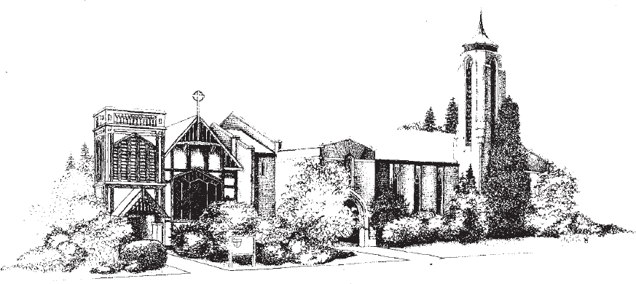

Wherever you are on your spiritual journey, you have a place at Epiphany.

1805 38th Avenue | Seattle, WA 98122 206-324-2573 | [www.epiphanyseattle.org](http://www.epiphanyseattle.org/)